November 2019

Welcome to Brookfield Surgery
Have you had your Flu Vaccination?
PATIENTS CAN ONLY HAVE
A FLU INJECTION
IF THEY FALL UNDER THE FOLLOWING RISK GROUPS:
OVER 65
HEART DISEASE
CHRONIC RESPIRATORY DISEASE, ASTHMA
CHRONIC KIDNEY DISEASE, CHRONIC LIVER DISEASE
NEUROLOGICAL DISEASE, DIABETES
IMMUNOSUPPRESSION
MULTIPLE SCLEROSIS,
CARER, PREGNANT
The surgery will be closed for staff training on:
Thursday 28 November 2019

Patient Reference Group.
The Patient Reference Group is a very informal feedback session.
We will always welcome new members, or comments so if you are a patient of Brookfield Surgery and would like some more information please ask at Reception.
Our next meeting is: Thursday 6 February 2020 12.30-1.30pm

SAY HELLO AND WAVE GOODBYE
We are delighted to welcome Debbie Taylor the new Practice Manager to Brookfield Surgery. Debbie has 30 years’ experience in General Practice and is looking forward to the challenge.

We welcome our new GP Registrars – Dr James Roberts, Dr Afra Gangi & Dr Muataz Khalid

SystmOnline Modules
You can now book your appointment and order your prescription online. Ask at reception for a registration PIN
Did you know the Practice has a website
www.brookfieldsurgery.co.uk
Our website contains all the information that you need to know about us and the services that we offer as well as health promotion details.
FRIENDS AND FAMILY TEST
As from 1st December 2014 if you visit our GP Surgery you will be able to complete a Friends & Family short form, stating whether or not you would recommend us to your friends and family if they need similar care or treatment.
Your answers will be anonymous and can be put in the box provided, which are located in our waiting area. You will also receive a text message after your visit to the Practice asking for your feedback. It is important to the practices that we review and listen to your feedback.
SEPTEMBER FRIENDS AND FAMILY RESPONSES
Sept 19  9 | EXTREMELY LIKELY | LIKELY | NIETHER LIKELY NOR UNLIKELY | UNLIKELY | EXTREMELY UNLIKELY | DON’T KNOW
responses | 50 | 1 | 1 | 2 | 3 | 1
comments | Extremely Likely  Efficient, Professional Service  Fantastic Service  I consider Dr Finigan an excellent Doctor whom I have faith in  Very Pleasant Nurse  Wasn’t aware the appointment I had was to discuss one concern only  Easy to get an appointment on the same day, short waiting time and excellent service from Doctor  Very good nurse – was five minutes late but she still was very helpful  Brookfield Surgery – Feedback for Patients  Many thanks for all your feedback.  We constantly review our appointment system and review capacity and demand to ensure we have good availability across our clinical team.  All your comments are fed back to the whole team – We very much appreciate all your positive feedback

Military Veterans Posted
Veterans' Gateway
Are you a military veteran? If so and you need help or advice over the festive period, you can contact the Veterans’ Gateway on 0808 802 1212. The service is available 24/7, including on Christmas Day. For more information, visit: www.veteransgateway.org.uk
Have you had a bowel screening kit sent to you – Have you responded ??

If you’re taking care of number 1…check your number 2’s!
If you were recently sent a bowel cancer screening kit to test your bowel motion (faeces/ poo) but haven’t sent it back yet.  I would like to remind and encourage you to complete and send back your screening kit. | 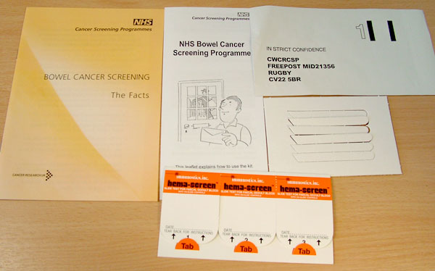  The Bowel Cancer screening kit contains testing kit, sample sticks, leaflet & prepaid envelope
The signs and symptoms of bowel cancer often go unnoticed until the disease is already well developed, but if caught early enough 90% of bowel cancers can be successfully treated.
If you would like to discuss anything further please call the NHS Bowel Cancer Screening Programme freephone helpline on 0800 707 6060 (Calls are free from UK landlines).
As your GP, I would like to encourage you to complete your bowel cancer screening kit as soon as possible. If you no longer have your kit, please call 0800 707 6060 to request a new kit. Once you have received the screening kit, if you have any questions please call 0800 707 6060.

Care Quality Commission
Brookfield Surgery
CQC overall rating Good
Read our report from June 2016 on our website www.brookfieldsurgery.co.uk
Annual Regularity Telephone Review 4 September 2019
NHS HEALTH CHECKS
The NHS Health Check is a health check-up for adults in England aged 40-74. It's designed to spot early signs of stroke, kidney disease, heart disease, type 2 diabetes or dementia. As we get older, we have a higher risk of developing one of these conditions. An NHS Health Check helps find ways to lower this risk.
How do I get an NHS Health Check?
If you're in the 40-74 age groups without a pre-existing condition, you can expect to receive a letter from your GP inviting you for a free NHS Health Check every five years. Speak to one of our receptionists for further information.
How can I improve my test results?
Once you've had your NHS Health Check, your healthcare professional will discuss your results with you. You'll be given advice to help you lower your risk of a stroke, kidney disease, heart disease, diabetes or dementia, and maintain or improve your health. But you don't have to wait until then to make healthy changes.
Brookfield Surgery has recently had technical issues with its phone system. We do apologize for any inconvenience caused. We are hoping the problem is now resolved but please contact the Practice Manager if you are experiencing problems contacting the surgery.
Patient Experience Survey Results
