Welcome to Brookfield Surgery Patient Newsletter
Tel: 01925 756969 Website: www.brookfieldsurgery.co.uk/
May 2022
Our doors are open for patients to access the surgery. If you would prefer to use our intercom at main front reception door, please do so. Please be patient, as our receptionist are also dealing with phone calls and other queries so will attend to your query as soon as possible.
We ask patients to continue to wear their face mask throughout the surgery and regularly use hand sanitiser entering and exiting the surgery to keep patients and staff safe.
Say Hello
We are delighted to welcome our new GP Registrars, Dr N Biswas and Dr J Yannis-Gerges.
Changes to our appointment System
During these unprecedented times, we thank you for your continuing support. We have made some changes to our appointment system to ensure patients are directed to the most appropriate health care clinician and service.
Appointments

We offer face to face, telephone and online consultations.

E-Consult is available for administrative requests and non-urgent minor problems (subject to availability). Your e-Consult will be assessed within 2 working days and if necessary, an appointment will be made via the telephone or face to face up to two weeks ahead.

Before you submit an e-consult consider the alternatives. The pharmacist at your local chemist is highly trained in offering a wide range of services and may be able to give you the help you need, so you won’t have to spend time waiting for an appointment

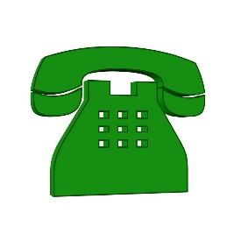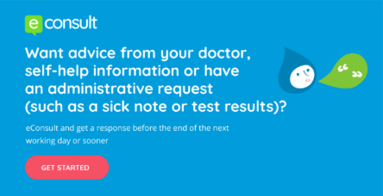
Signposting patients to healthcare services

We have a large group of clinicians working together providing health care appointments. These include:
- First contact Physio
- Mental Health Practitioner
- Local Pharmacist
- Care Coordinator
- Advanced Nurse Practitioner
- Social Prescriber
- Practice Nurse
- Clinical Pharmacist
- Community Paramedic
It may be necessary for one of the above clinicians to review you.
PLEASE HELP THE PRACTICE TO HELP YOU WITH YOUR HEALTH CARE NEEDS
Nurses Appointments
We are pleased to announce Nurse Geggie role has developed and Carole is now working as an Advanced Nurse Practitioner, supporting clinical and administration with triaging your clinical needs.
Phlebotomy Clinics
We ask patients who can do so, to attend local phlebotomy clinics for routine bloods, available at Bath Street, Orford Jubilee Park and Warrington Hospital. If you have been asked to have bloods taken and are attending local clinics, please ensure you collect a blood form from reception.
COVID Spring Booster Vaccinations
Due to COVID vaccine availability – we have been unable to hold and plan clinics for the spring booster’s programme as vaccine supply has been low. We are receiving regular updates from Warrington Clinical Commissioning Groups and are planning future clinics.
We ask patients to please not call the surgery regarding the delivery of the spring booster programme. Patients who are eligible for spring boosters and are 6 months post the 1st booster vaccination, will receive an invitation from the surgery. Alternatively, patients are able to book via the National Booking Service by visiting: https://www.nhs.uk/conditions/coronavirus-covid-19/coronavirus-vaccination/book-coronavirus-vaccination/
or contacting the National Booking Service (119).
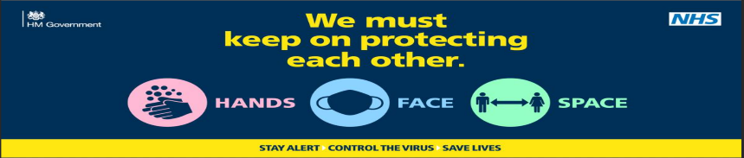
Patient Participation Group
The patient participation Group (PPG) is a very informal feedback session. We will always welcome new members, or comments, so if you are a patient of Brookfield Surgery and would like some more information please ask at Reception.
We are holding a PPG meeting on Monday 9th May 2022.

Self-Check In Machine Main Building
Our Self check in machine is currently in the process of being updated and we are hoping to have this up and running in the main building in the next couple of weeks. This will enable patients to self-check in for their appointment. This service is very beneficial to both patients and the surgery and therefore, in the meantime our reception desk may be more busier than usual whilst we wait for the self-check in machine to be updated and re-installed.

Jayex Notification Board
We are pleased to have our Jayex notification TV boards back up and running in the waiting rooms. We can provide patients with update to surgery information and most recent health campaigns.
Waiting Rooms
We have increased the number of chairs within our waiting rooms, and we kindly ask patients to please social distance where possible and respect other patients.
Face Masks
Polite notice:
We ask all patients who attend the surgery to wear a face mask, unless exempt. Face masks are mandatory within health care settings and therefore, in accordance with Government COVID-19 guidelines you will be asked to wear one whilst in the surgery, unless exempt.
Friends and Family
When you visit our GP Surgery you will be able to complete a Friends & Family short form, stating whether or not you would recommend us to your friends and family if they need similar care or treatment. Your answers will be anonymous and can be completed at the surgery, please post feedback in the box provided, which are located in our waiting area. It is important to the practices that we review and listen to your feedback.
March 2022 feedback:
“The service provided was as expected. On time and blood results were explained in detail with good advice from Jane Newsholme the practice nurse”
“Thorough, efficient and friendly approach”
“Very friendly nurse and understanding”
We thank patients for providing the surgery with feedback and we share this at our staff meetings to improve our services.

March E-Consult Feedback
Brookfield Surgery has been working hard throughout the covid-19 pandemic changing how we see patients following NHS guidance. We welcome both positive and negative feedback to help improve services for our patients.
What were your patients’ care outcomes after using eConsult?
67% - patients who said their issue was completely resolved seven days after using the service.
67% - patients who did NOT have to contact the GP practice or any other health services for the same problem in a week after consulting online.
Did patients say they were contacted in time?
100% - patients who said they were contacted by the stated response time.
How did patients hear about eConsult?
67% - ‘From the GP practice website’.
17% - ‘Another patient, family member or friend told me about it’.
17% - Someone else from the GP practice told me about it’.

