February/March

Welcome to Brookfield Surgery

NEW APPOINTMENT SYSTEM FROM TUESDAY 18 FEBRUARY 2020
Brookfield Surgery has recognised it needs to change the way it meets patient demand to ensure we are safe and effective.
We understand that different patients want different things from our appointment system. Some people like to fit appointments in with their work or other commitments whilst some need to be seen as urgent on the day. Many people have more routine matters to discuss whilst other people have potentially life threatening health issues needing prompt attention.
We try our best to meet these varying needs within the limitations of the number of GPs and appointments available. Like most GP surgeries, the demand for GP appointments here at Brookfield Surgery is very high. Every month our GPs provide well over 2500 consultations for patients and demand continues to rise. Therefore our receptionists will normally ask you a few questions to help you find the most appropriate point of care.
URGENT APPOINTMENTS ON THE DAY
The Doctors at Brookfield Surgery would like all patients to use the new eConsult online service for appointments on the day that you feel cannot wait for a book ahead appointment
"eConsult is a quick and efficient way to resolve health issues without the stress of repeated phone calls to try and get through to a busy reception while staying at your own NHS GP.
All under 5 year old children will be telephone triaged by the GP
If you access our website www.brookfieldsurgery.co.uk
Click on the eConsult box
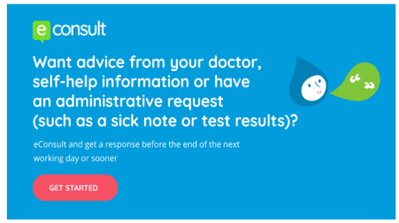
The GP will receive your eConsult and contact you back with your request. Please note if your request is urgent you will be booked an appointment for a GP. At such short notice there is much less flexibility over the time of the appointment and choice of clinician. If the GP feels you can be triaged over the telephone or directed to the pharmacy they will assess your needs.

If you walk into the practice asking for an on the day appointment you will be directed to complete the eConsult in the waiting room or asked to complete at home and the GP will contact you back.
If you do not have internet access the GP will ring you and triage your request.
Booked in advance
Bookable up to 4 weeks ahead, these provide choice and flexibility as to when and by whom you are seen. If these appointments are filled on a particular day the receptionist will look for an acceptable alternative. Other appointments are released daily to make it easier for you to see your usual GP with a problem that is not urgent but you would like to be seen within a few days. A number of appointments are also available to book online.
The surgery will be closed for staff training on:
Thursday 27 February 2020

Patient Reference Group.
The Patient Reference Group is a very informal feedback session.
We will always welcome new members, or comments so if you are a patient of Brookfield Surgery and would like some more information please ask at Reception.
Our next meeting is: Thursday 5 March 2020 12.30-1.30pm
SystmOnline Modules
You can now book your appointment and order your prescription online. Ask at reception for a registration PIN
Did you know the Practice has a website
www.brookfieldsurgery.co.uk
Our website contains all the information that you need to know about us and the services that we offer as well as health promotion details.

Military Veterans Posted
Veterans' Gateway
Are you a military veteran? If so and you need help or advice over the festive period, you can contact the Veterans’ Gateway on 0808 802 1212. The service is available 24/7, including on Christmas Day. For more information, visit: www.veteransgateway.org.uk
Brookfield Surgery
CQC overall rating Good
Read our report from June 2016 on our website www.brookfieldsurgery.co.uk
Annual Regularity Telephone Review 4 September 2019

FRIENDS AND FAMILY TEST
As from 1st December 2014 if you visit our GP Surgery you will be able to complete a Friends & Family short form, stating whether or not you would recommend us to your friends and family if they need similar care or treatment.
Your answers will be anonymous and can be put in the box provided, which are located in our waiting area. You will also receive a text message after your visit to the Practice asking for your feedback. It is important to the practices that we review and listen to your feedback.
January FRIENDS AND FAMILY RESPONSES
JAN 20  9 | EXTREMELY LIKELY | LIKELY | NIETHER LIKELY NOR UNLIKELY | UNLIKELY | EXTREMELY UNLIKELY | DON’T KNOW
responses | 67 | 3 | 0 | 2 | 2 | 0
comments | Extremely Likely  Dr Turner was excellent and took time to listen to me I have so much confidence in him  Dr Allen was excellent very personable and extremely helpful  Good Service  Happy with the treatment from Doctor White  Efficient professional and friendly service  Such an efficient and friendly practice. Working in NHS for 34 years and I am proud of you. All staff I have encountered during last 2 years of my worst health has been so supportive. How you are progressing and embracing different ways of working. Well done

Brookfield Surgery – Feedback for Patients
Many thanks for all your feedback.
Excellent reviews this month – thank you to all our patients that have taken the time to leave positive feedback.
We will be implementing a new appointment system on Tuesday 18 February 2020

SINGLES VACCINATION

You're eligible for the shingles vaccine if you're aged 70 or 78 years old.
In addition, anyone who was previously eligible (born on or after 2 September 1942) but missed out on their shingles vaccination remains eligible until their 80th birthday.
When you're eligible, you can have the shingles vaccination at any time of year.
The shingles vaccine is not available on the NHS to anyone aged 80 and over because it seems to be less effective in this age group.
Ask at Reception
Have you had a bowel screening kit sent to you – Have you responded ??

If you’re taking care of number 1…check your number 2’s!
If you were recently sent a bowel cancer screening kit to test your bowel motion (faeces/ poo) but haven’t sent it back yet.  I would like to remind and encourage you to complete and send back your screening kit. | 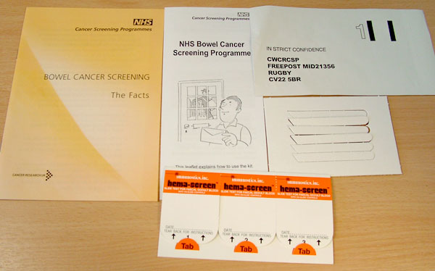  The Bowel Cancer screening kit contains testing kit, sample sticks, leaflet & prepaid envelope
The signs and symptoms of bowel cancer often go unnoticed until the disease is already well developed, but if caught early enough 90% of bowel cancers can be successfully treated.
If you would like to discuss anything further please call the NHS Bowel Cancer Screening Programme freephone helpline on 0800 707 6060 (Calls are free from UK landlines).
As your GP, I would like to encourage you to complete your bowel cancer screening kit as soon as possible. If you no longer have your kit, please call 0800 707 6060 to request a new kit. Once you have received the screening kit, if you have any questions please call 0800 707 6060.

Care Quality Commission
NHS HEALTH CHECKS
The NHS Health Check is a health check-up for adults in England aged 40-74. It's designed to spot early signs of stroke, kidney disease, heart disease, type 2 diabetes or dementia. As we get older, we have a higher risk of developing one of these conditions. An NHS Health Check helps find ways to lower this risk.
How do I get an NHS Health Check?
If you're in the 40-74 age groups without a pre-existing condition, you can expect to receive a letter from your GP inviting you for a free NHS Health Check every five years. Speak to one of our receptionists for further information.
How can I improve my test results?
Once you've had your NHS Health Check, your healthcare professional will discuss your results with you. You'll be given advice to help you lower your risk of a stroke, kidney disease, heart disease, diabetes or dementia, and maintain or improve your health. But you don't have to wait until then to make healthy changes.

