Brookfield Surgery

Appointment system
APRIL2023

How to access the practice?  We would encourage patients to only attend the surgery if you have an appointment or have been asked to.  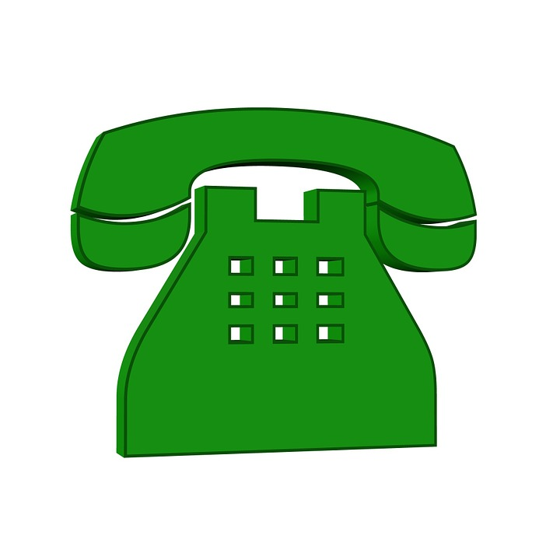  Please call the surgery on 01925 756 969 to book an appointment. The reception team will ensure your appointment request is directed to the most appropriate health care clinician.  We book appointments 2 weeks in advance.  Only urgent cases will be assessed and dealt with on the day by the Duty Clinician. |  |  | Mission Statement  We at Brookfield Surgery are committed to working together to provide quality health care to our patients. We will work with patients to promote good health and prevent illness. We aim to be courteous and efficient at all times and will continue to review and improve our services.  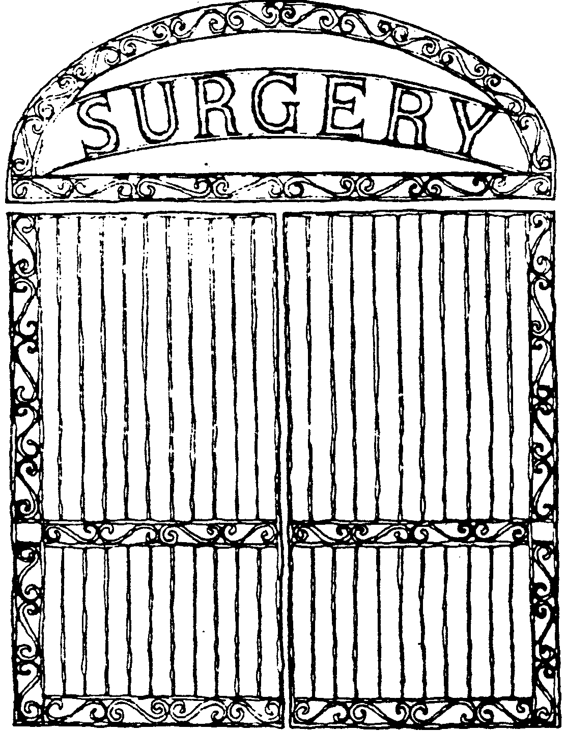 Contact Us  Brookfield Surgery  Whitbarrow Road  Lymm  Cheshire  WA13 9DB  Phone: 01925 756969  Email: cmicb-war.brookfieldadmin@nhs.net  Web: www.brookfieldsurgery.co.uk

Appointments  We offer face to face, telephone and online consultations.  The Practice uses Patchs as an online consultation platform for patients to submit a non urgent appointment request or administrative request. Your Patchs will be assessed within 2 working days and if necessary, an appointment will be made via the telephone or face to face up to two weeks ahead. You may be sent an appointment via a text message to one of our network clinics. This could include a physio appointment, minor aliment appointment, extended access appointment at Latchford, Stockton Heath or Lakeside Surgery.  Before you submit a Patchs consider the alternatives. The pharmacist at your local chemist is highly trained in offering a wide range of services and may be able to give you the help you need, so you won’t have to spend time waiting for an appointment |  |  | Out of Hours Extended Access Appointment  Pre bookable, evening and weekend GP appointments to suit you. There are a wide range of GP appointments available to fit into your lifestyle.  Pre-bookable evening and weekend appointments with a local GP are available from 6pm-8pm Monday-Friday and Saturday and Sunday. The appointment might be at another local Practice.  To access an extended access appointment, please call us and we will arrange the appointment for you.  Please be aware that you will need to consent to share your medical record with the GP who is on call in the Extended Access Service.

Attached Clinicians  We have a large group of clinicians working together providing health care appointments. These include:  - First contact Physio  - Mental Health Practitioner  - Local Pharmacist  - Care Coordinator  - Advanced Nurse Practitioner  - Social Prescriber  - Practice Nurse  - Clinical Pharmacist  - Community Paramedic  It may be necessary for one of the above clinicians to review you at one of our neighbouring clinics. |  |  | Prescriptions  Please do not telephone the surgery to order your prescription or check your prescription is ready as this is putting additional pressure on our telephones. Please contact your chemist.  Prescriptions are processed within 2 working day.  How do I order prescriptions?  If you have online access to your records, you can order your prescriptions online at www.brookfieldsurgery.co.uk  or email cmicb-war.brookfieldpm@nhs.net

