Brookfield Surgery

AUGUST’S  PATIENT  NEWSLETTER |  | What’s new?  Welcome Doctor Ahmed & Dr Kumar  GP Registrars  What’s HAPPENED?  Flu clinics will start on 5.10.2024 appointment texts have already been sent out.
Dr LEECH message  ‘Thank you to those who responded to our patient survey earlier this year. We have been working hard behind the scenes with our team and PPG to review your responses and we hope that you start to see some improvements in the coming months’ | 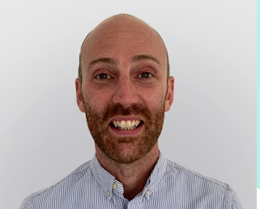
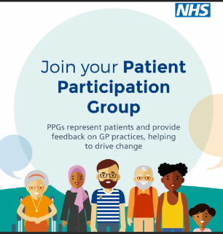 | What is a Patient participation group  (PPG)  A group of patients, carers and staff who meet to discuss service issues, new innovations, and patient experiences to support improving services. Email  cmicb-war.brookfieldadmin@nhs.net  to join our team
 |  | 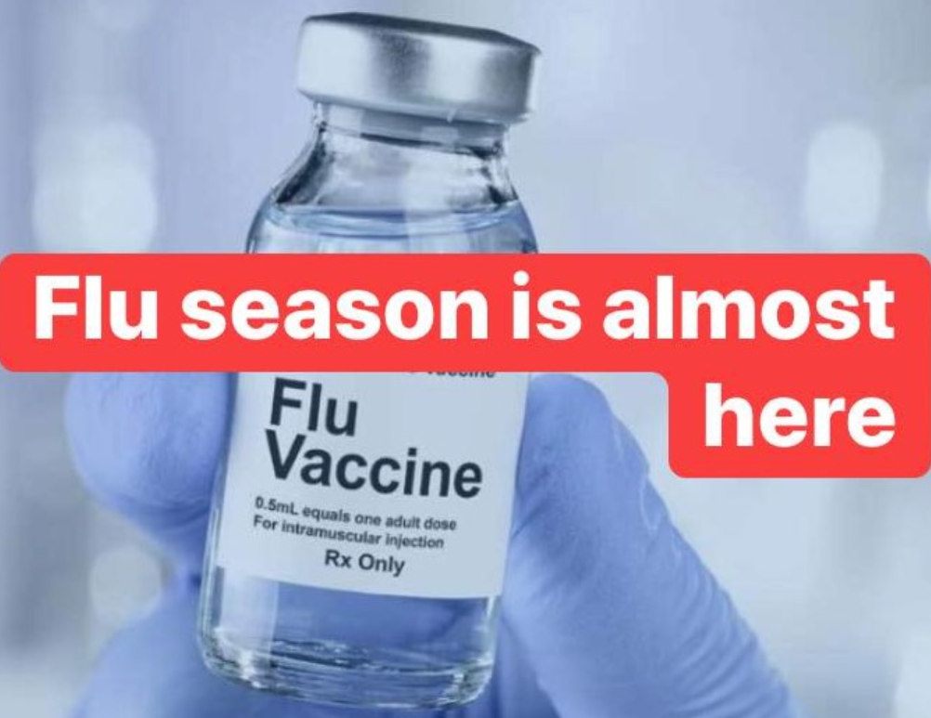
september Training  The medical Centre will be closed on the following dates for staff training from 1pm.  - SWAN PLT – 04.09.24  - Educational PLT – 26.09.24 | NHS HEALTH CHECKS  The NHS Health Check is a health check-up for adults in England aged 40-74. It's designed to spot early signs of stroke, kidney disease, heart disease, type 2 diabetes or dementia. As we get older, we have a higher risk of developing one of these conditions. An NHS Health Check helps find ways to lower this risk. Book your appointment today.

Would you recommend Brookfield Surgery to your family, friends or colleagues?
Extremely Likely | Likely | Neither likely nor unlikely | Unlikely | Extremely unlikely | Don’t know
5 | 0 | 1 | 0 | 1 | 0
Responses
Welcoming Staff
Excellent Service
Rita on reception is always so professional, kind, helpful and lovely
Doctor Lynch has been incredibly professional, thorough and kind every time
All Staff (Doctors Nurses and Reception Team) friendly, helpful and efficient
You have helped my family for 50+ years
Brookfield Surgery Feedback for patients
Many thanks for all your comments
All your comments will be discussed in our clinical meeting.
Our reception team always try to ensure patients are treated respectively and with care and consideration.
Many thanks

Have you had a bowel screening kit sent to you – Have you responded ?? 60 to 74 years
If you’re taking care of number 1…check your number 2’s!
If you were recently sent a bowel cancer screening kit to test your bowel motion (faeces/ poo) but haven’t sent it back yet.  I would like to remind and encourage you to complete and send back your screening kit. | The Bowel Cancer screening kit contains testing kit, sample sticks, leaflet & prepaid envelope
The signs and symptoms of bowel cancer often go unnoticed until the disease is already well developed, but if caught early enough 90% of bowel cancers can be successfully treated.
If you would like to discuss anything further please call the NHS Bowel Cancer Screening Programme freephone helpline on 0800 707 6060 (Calls are free from UK landlines).
As your GP, I would like to encourage you to complete your bowel cancer screening kit as soon as possible. If you no longer have your kit, please call 0800 707 6060 to request a new kit. Once you have received the screening kit, if you have any questions please call 0800 707 6060.

