Brookfield Surgery has recognised it needs to change the way it meets patient demand to ensure we are safe and effective.
We understand that different patients want different things from our appointment system. Some people like to fit appointments in with their work or other commitments whilst some need to be seen as urgent on the day. Many people have more routine matters to discuss whilst other people have potentially life threatening health issues needing prompt attention.
We try our best to meet these varying needs within the limitations of the number of GPs and appointments available. Like most GP surgeries, the demand for GP appointments here at Brookfield Surgery is very high. Every month our GPs provide well over 2500 consultations for patients and demand continues to rise. Therefore our receptionists will normally ask you a few questions to help you find the most appropriate point of care.

Booked in advance
Bookable up to 4 weeks ahead, these provide choice and flexibility as to when and by whom you are seen. If these appointments are filled on a particular day the receptionist will look for an acceptable alternative. Other appointments are released daily to make it easier for you to see your usual GP with a problem that is not urgent but you would like to be seen within a few days. A number of appointments are also available to book online.

URGENT APPOINTMENTS ON THE DAY
The Doctors at Brookfield Surgery would like all patients to use the new eConsult online service for appointments on the day that you feel cannot wait for a book ahead appointment
"eConsult is a quick and efficient way to resolve health issues without the stress of repeated phone calls to try and get through to a busy reception while staying at your own NHS GP.
All under 5 year old children will be telephone triaged by the GP
If you access our website www.brookfieldsurgery.co.uk
Click on the eConsult box

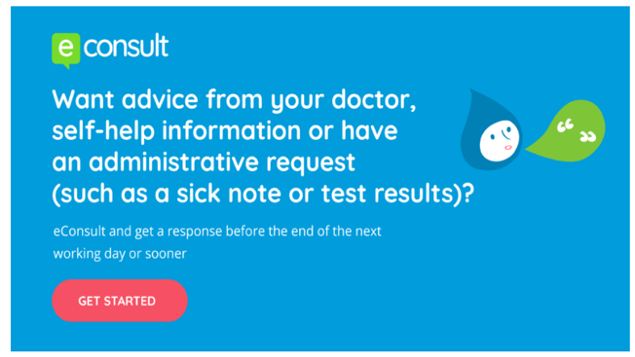

The GP will receive your eConsult and contact you back with your request. Please note if your request is urgent you will be booked an appointment for a GP. At such short notice there is much less flexibility over the time of the appointment and choice of clinician. If the GP feels you can be triaged over the telephone or directed to the pharmacy they will assess your needs.

If you walk into the practice asking for an on the day appointment you will be directed to complete the eConsult in the waiting room or asked to complete at home and the GP will contact you back.
If you do not have internet access the GP will ring you and triage your request. uality

Telephone Appointments
We have made available book ahead telephone appointments for patients who do not need to be seen but wish to discuss their medical care on the telephone. These appointments are available to be booked ahead only. The receptionist will ask for brief details to ensure this approach is the most appropriate for your needs. They will give you the time frame in which your call will be returned; you may leave a mobile number but please ensure your mobile phone is switched on.

Extended Hours

We now offer extended access on a Tuesday evening from 6:30pm - 8:00pm for GP appointments and Treatment Room Nurse appointments. This service is for pre-booked routine appointments only - please speak to reception for further information

Please help us with the new appointment system as we will be able to offer quicker patient care using the new systems available

Patients who fail to attend their appointments

It is important that you inform the receptionist at your earliest convenience if you no longer require your appointment, this enables the appointment to become available to another patient

Thank you to all our patients for their help and support during this transition time

Please speak to Debbie Taylor Practice Manager if you wish to discuss the appointments system further

